Exp-6

Aim: **Foundations for building data visualizations, Creating first visualization**

**Source code:**

**What is Data?**

Data refers to raw facts, statistics, or information collected or stored in a structured or unstructured form. Data can take various forms, such as text, numbers, images, videos, and more. It is the foundation of all information and knowledge and is used in various fields for analysis, decision-making, and understanding trends and patterns.

**Data can be categorized into two main types:**

* **Structured Data:** This type of data is organized into a specific format, such as tables or databases, and is easily searchable and analyzable. Examples include spreadsheets, relational databases, and CSV files.
* **Unstructured Data:** Unstructured data lacks a specific format and can include text documents, social media posts, images, audio recordings, and more. Analyzing unstructured data often requires advanced techniques like natural language processing and image recognition.

**Where to Find Data?**

You can find data from various sources, depending on your specific needs:

* **Open Data Portals:** Many governments and organizations provide free access to a wide range of data through open data portals. Examples include Data.gov (United States) and data.gov.uk (United Kingdom).
* **Data Repositories:** Academic institutions, research organizations, and data enthusiasts often share datasets on platforms like Kaggle, GitHub, and the UCI Machine Learning Repository.
* **APIs (Application Programming Interfaces):** Some websites and services offer APIs that allow you to programmatically access and retrieve data. Examples include Twitter API, Google Maps API, and financial market APIs.
* **Web Scraping:** You can extract data from websites using web scraping tools and libraries like BeautifulSoup and Scrapy. However, be mindful of the website's terms of use and legal restrictions.
* **Surveys and Surveys:** You can conduct your own surveys or collect data through questionnaires and interviews.
* **IoT Devices:** Internet of Things (IoT) devices generate vast amounts of data that can be used for various purposes.
* **Commercial Data Providers:** Some companies specialize in selling datasets for specific industries, such as market research, finance, and healthcare.

**Foundations for Building Data Visualizations:**

Creating effective data visualizations requires a strong foundation in several key areas:

* **Data Analysis:** Before creating visualizations, you should thoroughly analyze your data to understand its structure, relationships, and any patterns or trends. Exploratory data analysis (EDA) techniques can help with this.
* **Statistical Knowledge:** Understanding basic statistics is essential for making meaningful interpretations of data. Concepts like mean, median, standard deviation, and correlation are commonly used in data visualization.
* **Domain Knowledge:** Having knowledge of the specific domain or subject matter related to your data is crucial for creating contextually relevant visualizations. It helps you ask the right questions and provide valuable insights.
* **Visualization Tools:** Familiarize yourself with data visualization tools and libraries such as matplotlib, Seaborn, ggplot2, D3.js, and Tableau. Each tool has its strengths and can be used for different types of visualizations.
* **Design Principles:** Study design principles, including color theory, typography, and visual hierarchy, to create visually appealing and effective visualizations. Avoid common pitfalls like misleading visualizations.
* **Interactivity:** Learn how to add interactive elements to your visualizations to engage users and allow them to explore the data. This can be achieved using tools like JavaScript, Python libraries, or dedicated visualization software.

**Creating Your First Visualization:**

To create your first data visualization, follow these general steps:

* **Select Your Data:** Choose a dataset that aligns with your goals and interests. Ensure that the data is clean and well-structured.
* **Define Your Objective:** Clearly define what you want to communicate or explore with your visualization. Are you looking to show trends, comparisons, or distributions?
* **Choose the Right Visualization Type:** Select a visualization type that suits your data and objectives. Common types include bar charts, line charts, scatter plots, histograms, and pie charts.
* **Prepare and Transform Data:** Preprocess your data as needed. This may involve aggregating, filtering, or transforming the data to fit the chosen visualization.
* **Create the Visualization:** Use a suitable tool or library to create your visualization. Customize it with labels, colors, and other design elements.
* **Interactivity (Optional):** If appropriate, add interactive features to your visualization to allow users to interact with the data.
* **Test and Iterate:** Review your visualization for accuracy and clarity. Seek feedback from others and make improvements as necessary.
* **Publish or Share:** Once you are satisfied with your visualization, publish it on a platform, embed it in a report, or share it with your intended audience.
* **Document and Explain:** Provide context and explanations for your visualization. Clearly communicate what the viewer should take away from it.
* **Maintain and Update:** If the data changes or new insights emerge, update your visualization accordingly.

Exp7

**AIM: Getting started with tableau software using data file formats, connecting tableau,creating**

**basic charts (line, bar charts, tree maps) using the show me panel.**

**Source code:**

Getting started with Tableau software is a great way to create data visualizations quickly and efficiently. Here are the steps to get started, including connecting your data to Tableau, creating basic charts like line charts, bar charts, and treemaps, and using the Show Me panel:

# 1. Download and Install Tableau:

First, you'll need to download and install **Tableau Desktop** or **Tableau Public** (a free version). Follow the installation instructions provided on the Tableau website for your specific operating system.

# 2. Prepare Your Data:

Before connecting your data to Tableau, ensure that your data is in a suitable format. Common data file formats that Tableau supports include **Excel (.xlsx), CSV (.csv), and text files (.txt)**. Make sure your data is organized with headers for each column.

# 3. Connect Your Data to Tableau:

3.1 Launch **Tableau Desktop.**

3.2 Go to "**File**" Menu and then click on "**Open**".

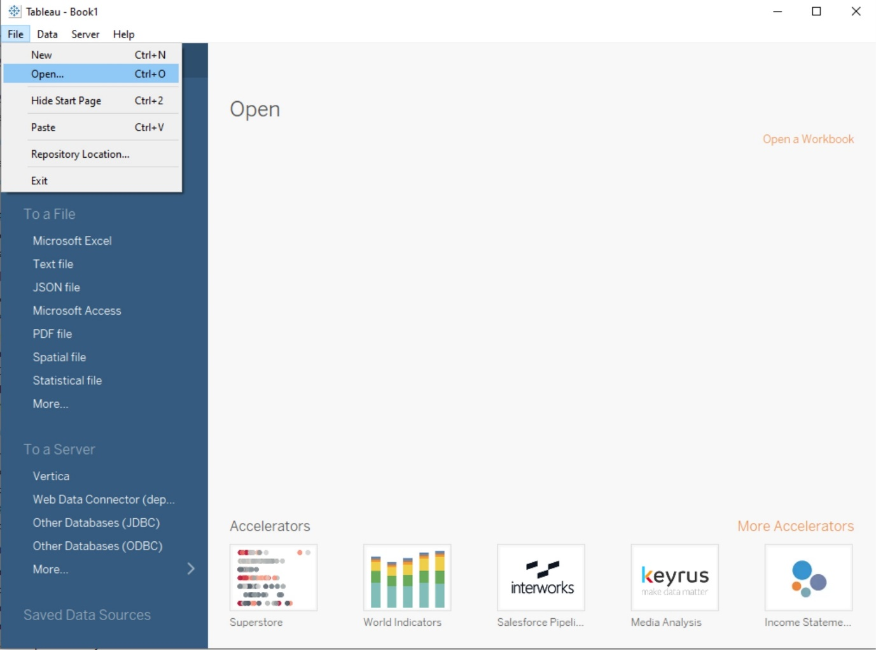

3.3 Choose the data source type (e.g., Excel, CSV, text file) and Select the data file(**P6-SuperStoreUS-2015.xls**) and click "Open".

3.4 Drag any table(e.g. Orders) into working area.

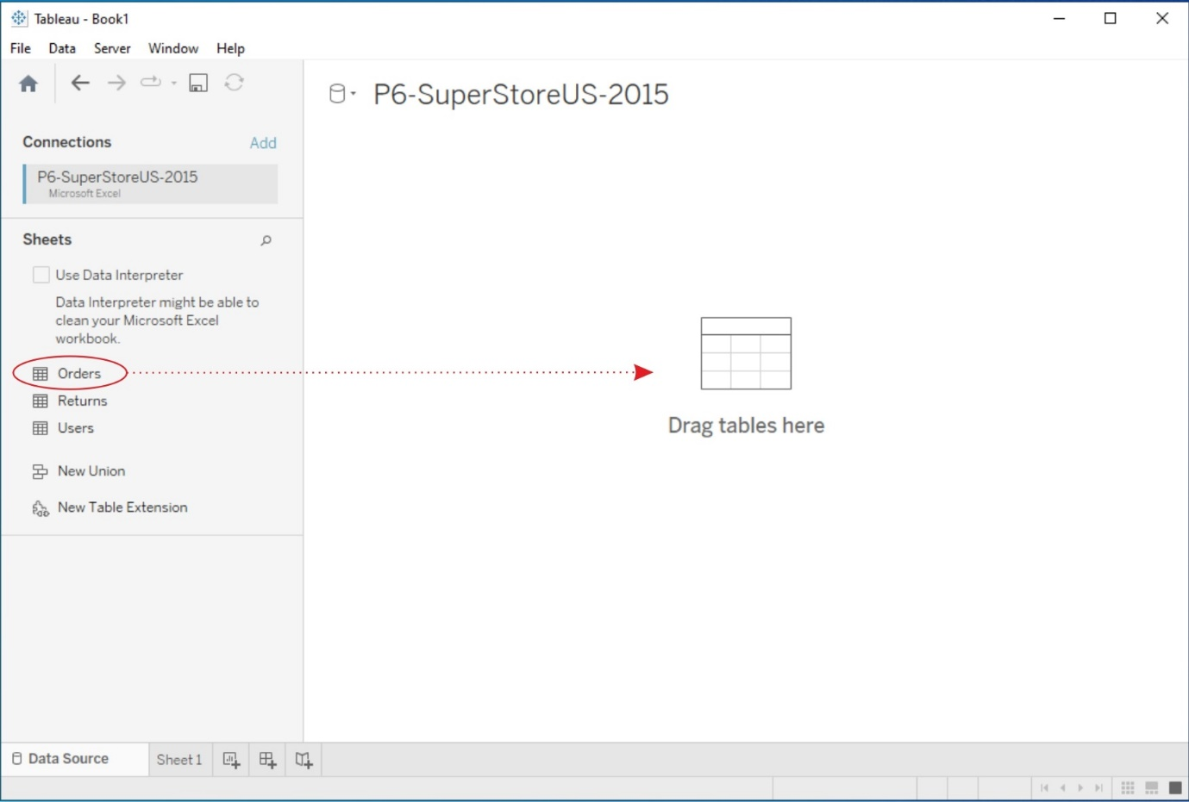

3.5 Click on Worksheet(**Sheet1**).

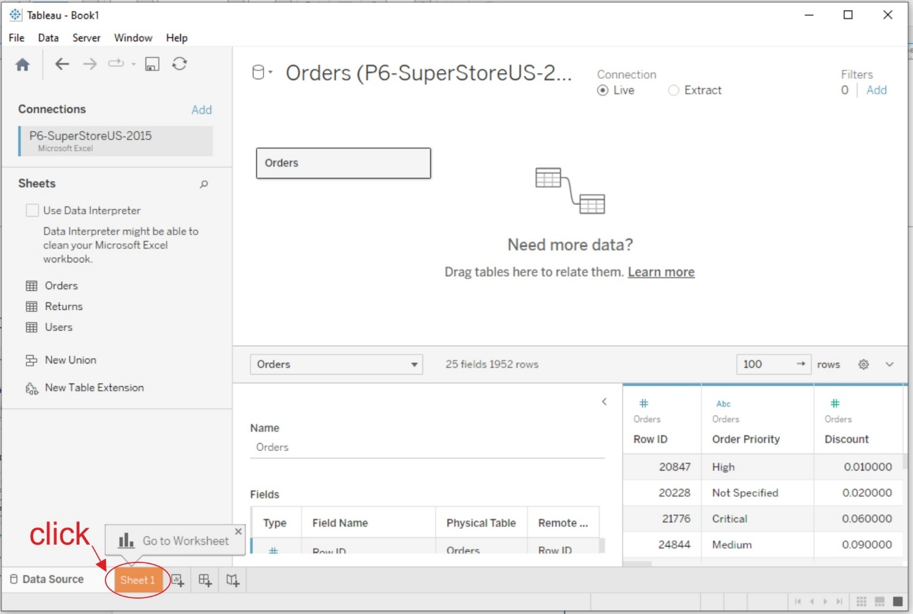

# 4. Data Source Pane:

Once your data is connected, the Data Source Pane will appear on the left-hand side of the Tableau interface. Here, you can see a preview of your data and perform data transformations or join multiple data sources if necessary.

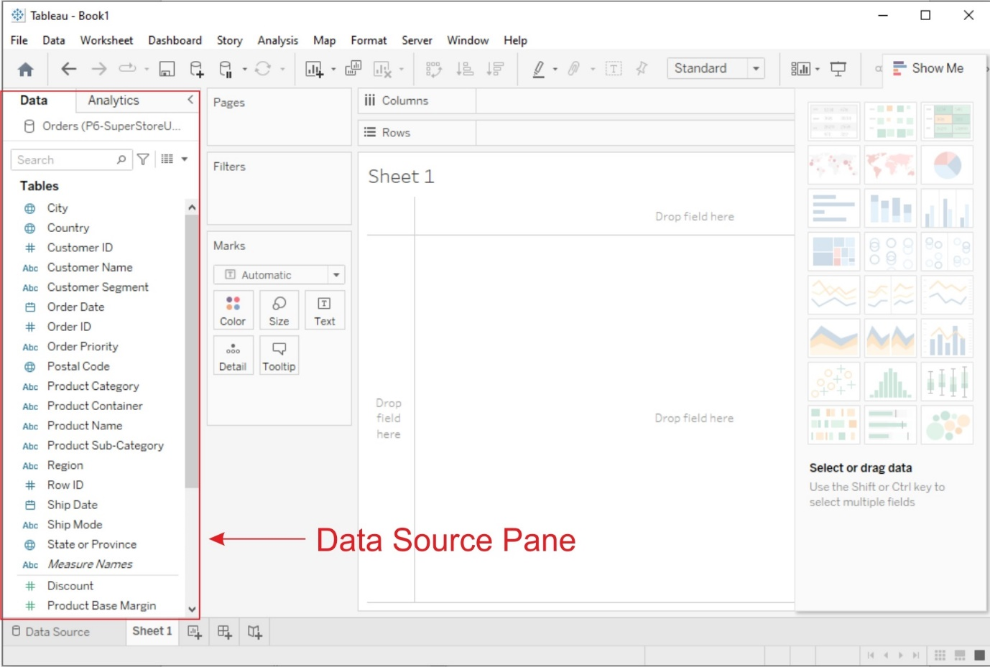

# 5. Creating Basic Charts:

Now, let's create some basic charts using Tableau:

## a. Line Chart:

1. From the "**Data Source pane**", drag and drop the date field to the **Columns shelf** and a numeric field (e.g., sales, revenue) to the **Rows shelf**.

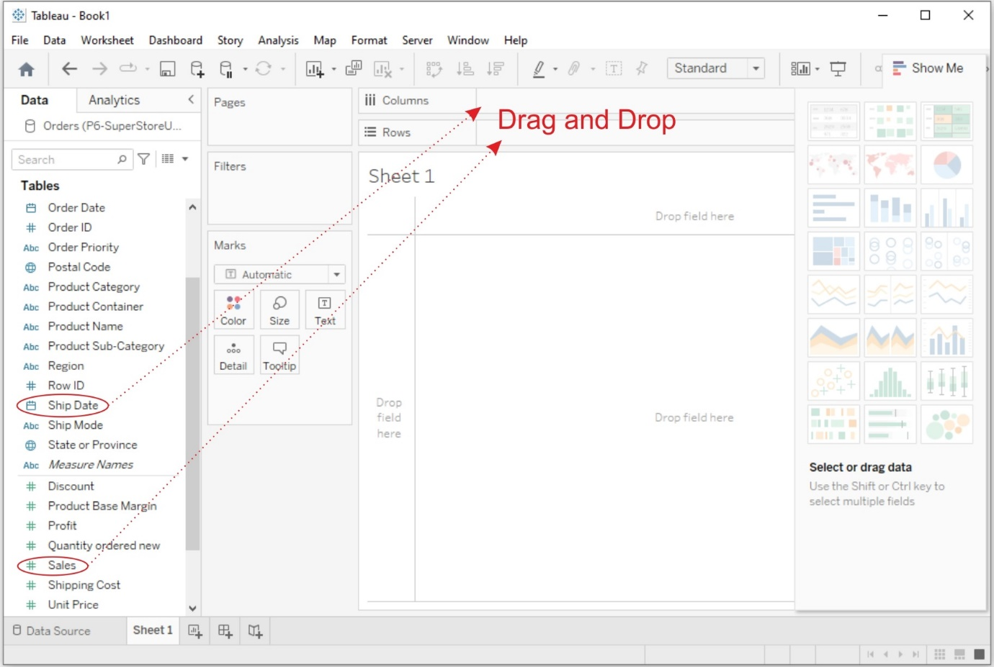

2. Then **Tableau** will automatically create a line chart. You can customize it by adding *labels, titles, and formatting*.

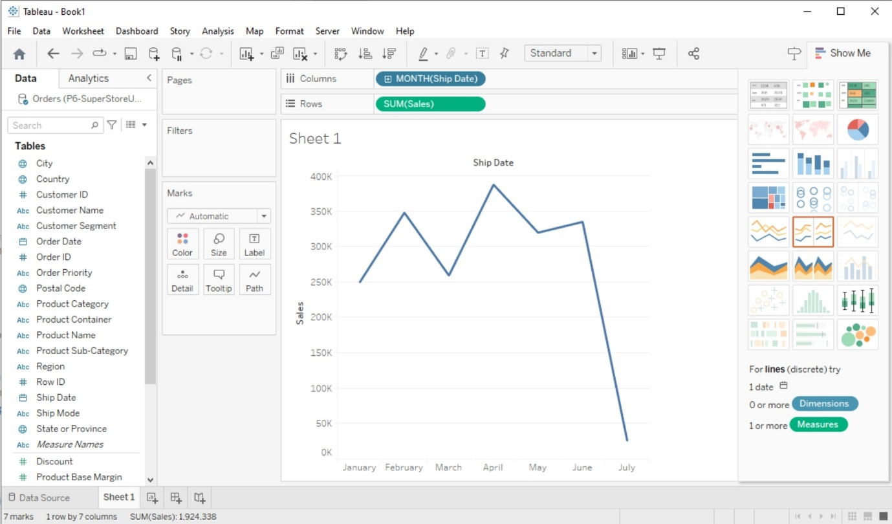

## b. Bar Chart:

1. Drag and drop a **categorical field** (e.g., product category, region) to the Columns shelf and a **numeric field** to the Rows shelf.

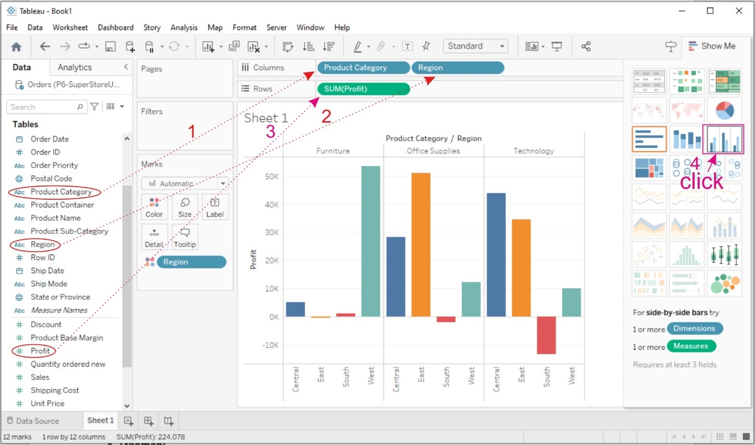

2. Then **Tableau** will create a bar chart. You can adjust the orientation and formatting as needed. To display Labels on the bars click on Lables and select "**Show mark lables**"

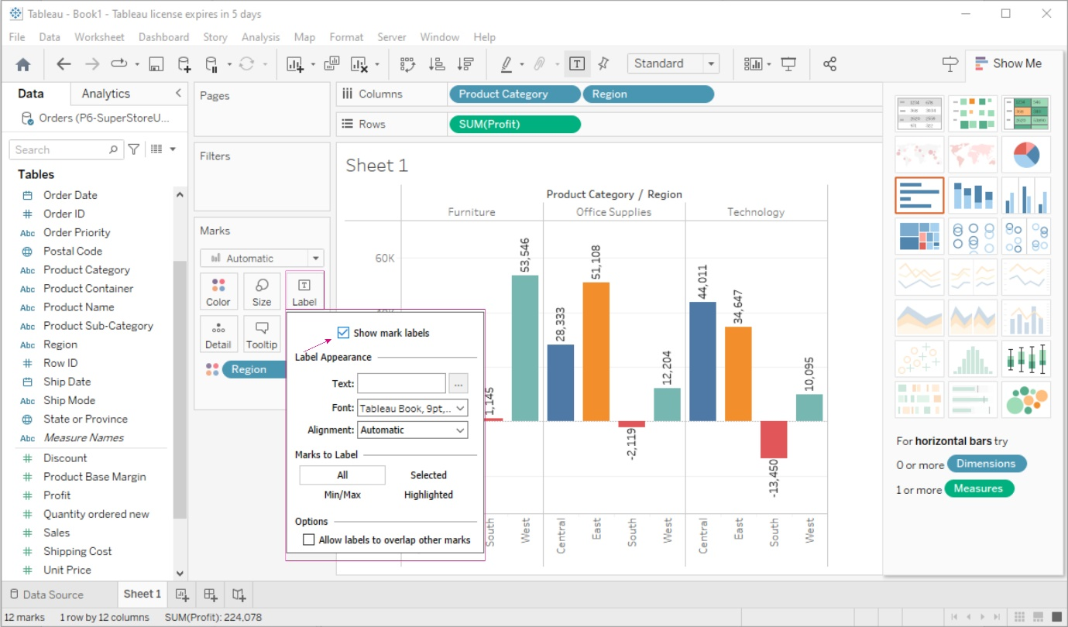

 c. Treemap:

1. Drag and drop a categorical field to the Columns shelf.

2. Drag and drop a numeric field to the Size shelf.

3. Tableau will create a treemap visualization. You can further customize it by adjusting colors and labels.

# 6. Using the Show Me Panel:

The Show Me panel in Tableau helps you explore various chart types based on your data and the fields you select. Here's how to use it:

1. After adding fields to the Rows and Columns shelves, click on the "Show Me" panel located on the left side of the Tableau interface.

2. In the Show Me panel, you'll see a variety of chart options that Tableau recommends based on your data. Click on a chart type to create it.

3. Tableau will automatically generate the selected chart type with your data. You can further customize it as needed.

4. To go back to the regular worksheet view, click the "Clear" button in the Show Me panel.

Exp 8